LECTURE 6
NETWORK SERVICES

1. Network Services and Resource
Network services are the functions that a network provides to users and computers so they can share data and use resources easily. These services are controlled by a special operating system called a Network Operating System (NOS). A normal operating system works for one computer, but a NOS is made to manage many computers connected in a network.
The main purpose of network services is resource sharing. A resource can be anything useful on the network, such as files, printers, applications, internet connection, or databases. Instead of every computer having its own printer or data copy, the network allows sharing. This reduces cost and improves efficiency.
Some common network services include:
- Web services (WWW) – Allow users to access websites through browsers.
- File sharing services – Let users store and access files from a central server.
- Mail services – Allow sending and receiving emails inside and outside the organization.
- Directory services – Store information about users, computers, and permissions.
- Remote management services – Allow administrators to control systems from another location.
- Print services – Manage shared printers so multiple users can print.
Most of these services use the TCP/IP protocol suite, which is a set of communication rules that allow devices to send and receive data correctly over the network. Without TCP/IP, devices would not understand each other.
In simple words, network services make communication possible, keep everything organized, and allow secure sharing of resources in an organization.

2. An Introduction to Network/NOS Services
A Network Operating System (NOS) is an operating system designed specially to manage network activities. Its main job is to control communication between computers and manage shared resources.
In a network, there are usually two types of systems:
- Clients – Computers that request services (like user PCs).
- Servers – Computers that provide services (like file servers, mail servers).
The NOS runs mostly on servers and allows them to provide services to clients. It manages:
- User accounts
- Passwords
- Permissions
- Shared folders
- Printers
- Applications
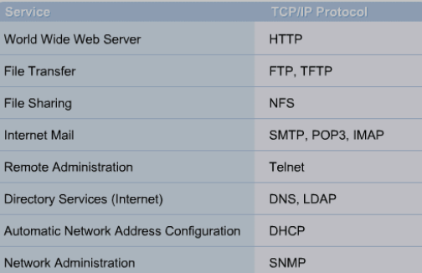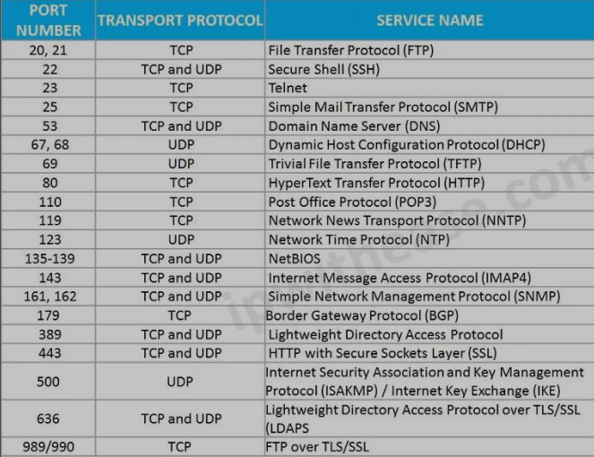
One important concept in NOS is authentication, which means verifying the identity of a user (checking username and password). Another concept is authorization, which means deciding what that user is allowed to access after login. These two help in security.
The NOS also helps in centralized management, meaning the administrator can control the entire network from one place instead of configuring each computer separately. This saves time and reduces errors.
Unlike a standalone operating system (like Windows on a home PC), a NOS focuses on network communication, security, and resource sharing.
In simple terms, the Network Operating System is the backbone of a network. It makes sure all computers talk properly, users are verified, resources are shared safely, and the whole system runs smoothly.

3. Remote Administration and Access Services
Remote Administration and Access Services allow users and system administrators to connect to a computer or network from a different physical location. This means they do not need to be physically present in the office or data center to access resources or manage systems.
These services are very important in modern networks because organizations may have multiple branches, remote employees, and servers located in secure data centers. Remote services make communication and management easier and faster.
There are two main uses of these services:
First is Remote Access for users, where employees connect to the company network from home, another city, or while traveling. After connecting, they can use files, applications, printers, and other internal services.
Second is Remote Administration, where system administrators manage servers remotely. They can create user accounts, install updates, fix problems, monitor performance, and control services without being physically near the server.
Because remote connections usually use the internet, security is very important. Authentication (verifying identity), authorization (checking permissions), and encryption (protecting data) are used to ensure safe communication.
In simple words, these services allow people to access and manage network systems from anywhere in a secure way.
3.1. What is Remote Access?
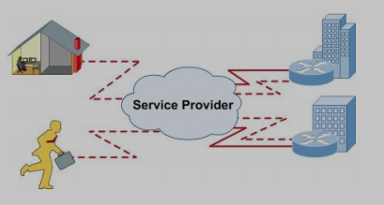
Remote access is the ability of a user to connect to a computer or network from a different location using a communication network such as the internet. It allows users to access organizational resources without being physically present in the office.
When a remote access connection is made, the user connects to a remote access server. The server checks the user’s identity through authentication methods such as username and password. In some systems, extra security like two-factor authentication may also be used.
After successful authentication, the user becomes part of the company network logically, even though they are physically outside the office. This means they can access shared folders, internal applications, email systems, databases, and other network resources just like they would from their office desktop.
Remote access works using special protocols and technologies that create a secure communication path between the user’s device and the company network. Often, a Virtual Private Network (VPN) is used to create an encrypted tunnel so that data cannot be easily intercepted by attackers.
However, remote access also introduces security risks. If weak passwords are used or the connection is not encrypted, attackers may:
- Guess passwords
- Capture data packets
- Perform denial of service attacks
- Gain unauthorized access
Therefore, strong authentication, encryption, firewalls, and monitoring systems are necessary to secure remote access connections.
In simple terms, remote access allows users to work from anywhere as if they are inside the office network, but it must be properly secured to prevent attacks.
3.2. Telecommuting
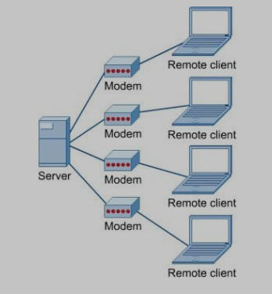
Telecommuting means working from a location outside the traditional office, usually from home, while staying connected to the company’s network through remote access technologies. It is also called remote working or work from home. In telecommuting, employees use the internet to connect to the company’s systems. They can access files, emails, databases, and applications just like they do in the office. This is possible because of remote access services such as VPN and remote desktop connections.
Telecommuting has several advantages for employees. It saves travel time, reduces transportation costs, and gives more flexibility in managing work and personal life. Employees can work comfortably without daily commuting.
It also benefits the organization. The company can reduce office space, electricity usage, and other operational costs. It may also increase employee productivity and satisfaction.
However, telecommuting also creates challenges. Since employees connect from outside networks, security risks increase. Home networks may not be as secure as office networks. Therefore, companies must use strong security methods such as encryption, firewalls, antivirus software, and secure authentication.
In simple words, telecommuting allows employees to work from home or other locations while still being connected to the company network.
3.3. Telnet Services
Telnet is one of the early Internet protocols used to create a connection between a local computer and a remote computer. It allows a user to log in to another machine over a network and control it as if they are physically present at that system.
Telnet works using the TCP/IP protocol suite and is mainly used for remote command-line access. When a Telnet connection is established, the user gets access to the remote system’s command prompt. From there, the user can execute commands, manage files, configure settings, and perform administrative tasks.
This makes Telnet useful for remote system management and troubleshooting. It was widely used by network administrators in early networking environments.
However, Telnet has serious security problems because it does not encrypt the data being transmitted. All information, including usernames and passwords, is sent in plain text over the network. This creates several security risks.
Security considerations of Telnet include:
Hacking – Attackers can try to gain unauthorized access to the remote system.
Password Guessing – Since Telnet requires username and password login, attackers may attempt brute force or guessing attacks.
Denial of Service (DoS) Attacks – Attackers may overload the Telnet service to make it unavailable for legitimate users.
Packet Sniffing – Because data is not encrypted, attackers can capture network packets and read sensitive information such as login credentials.
Due to these weaknesses, Telnet is considered insecure for modern networks. It has largely been replaced by more secure alternatives like SSH, which provide encrypted communication.
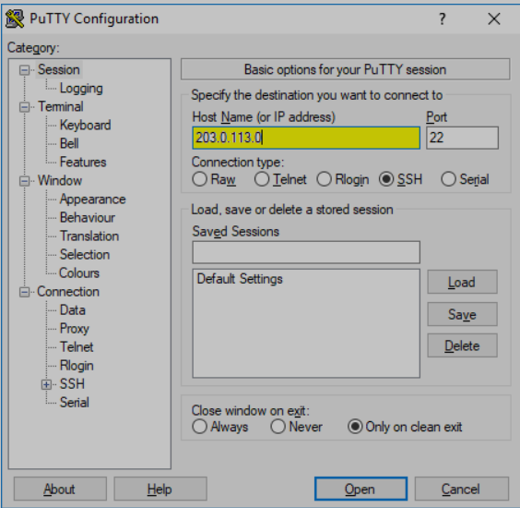
In simple terms, Telnet allows remote control of another computer, but it is not secure because it sends data without protection.
  - This picture shows the PuTTY configuration window.
It is used to set up and start a connection from your computer to a remote computer (server) over a network. In this screen, you enter the remote server’s IP address, choose the connection type (like SSH or Telnet), and specify the port number.
After clicking Open, PuTTY connects to the remote system so you can log in and control it from your PC.
In short, this screen is used to configure and start a remote connection to another computer.

4. Configuring Remote Access for a Client
Today, most computers are connected to a network permanently using a network interface card (NIC). This allows continuous communication with other devices in the network.
However, sometimes a computer is located in a place where it is not directly connected to the organization’s internal network. In such cases, a remote connection must be established using special protocols and technologies. These technologies allow the client computer to securely connect to the main network over the internet or another external network.
To configure remote access for a client, several important protocols are used:
Point-to-Point Protocol (PPP)
Point-to-Point Protocol (PPP) is used to create a direct communication link between two endpoints. These endpoints can be a client computer and a remote server. PPP is commonly used in dial-up and other direct connections. It helps in establishing, maintaining, and terminating the connection between the two devices.
In simple words, PPP allows two computers to communicate directly over a connection.
IPsec (Internet Protocol Security)
IPsec is a group of security protocols used to protect data sent over IP networks. It provides:
- Authentication (verifying identity)
- Encryption (protecting data from being read by attackers)
IPsec secures the transfer of IP packets over the internet. It ensures that the data is not modified or intercepted during transmission.
In simple terms, IPsec protects remote communication by making it secure and encrypted.
Point-to-Point Tunneling Protocol (PPTP)
PPTP is one of the oldest protocols used to create Virtual Private Networks (VPNs). It allows users to connect to a private network through the internet by creating a tunnel between the client and the server.
However, over time, PPTP has been found to have many security weaknesses. It is vulnerable to different types of attacks. Although it is not considered secure today, it is still used in some older systems.
Layer Two Tunneling Protocol (L2TP)
L2TP is another VPN protocol used to create a secure connection between a client and a server. However, L2TP alone does not provide encryption or strong authentication.
Because of this limitation, L2TP is usually combined with IPsec. When used together (L2TP/IPsec), the connection becomes secure because IPsec provides encryption and authentication.
- L2TP → Creates the tunnel (path between client and server).
- IPsec → Provides encryption and authentication to protect the data inside that tunnel.

4. Directory Service
4.1. Directory Servers
A Directory Server is a specialized server that stores and manages information about all network resources in an organization. It acts like a central database that keeps records of users, user groups, computers, printers, shared folders, telephone numbers, and other network objects.
The main purpose of a Directory Server is to provide centralized management and organization of network resources. Instead of storing user accounts and resource details separately on each computer, everything is kept in one structured system. This reduces duplication, prevents inconsistencies, and makes administration easier.
A Directory Server provides a lookup service, which means it helps find resources quickly. For example, when a user tries to access a shared printer or folder, the directory server maps that resource to its correct network address. This makes resource access faster and more efficient.
Another major purpose is centralized control and administration. System administrators can:
- Create and delete user accounts
- Reset passwords
- Assign users to groups
- Manage permissions
- Control access to resources
All of this can be done from one central location instead of configuring every computer individually. This saves time and reduces errors.
An important feature of directory servers is replication. Replication means copying the directory data to multiple physical servers. Even though the data exists on different servers, it appears as one unified directory to users and administrators. The purpose of replication is:
- Fault tolerance (if one server fails, another is available)
- Load balancing (multiple servers handle requests)
- Improved availability
In simple words, a Directory Server stores, organizes, and protects network information while making it easy to search and manage.
4.2. What is a Directory Service?
A Directory Service is the system or service that organizes and manages network information in a structured and hierarchical way. It defines how data is stored, accessed, and controlled within a network.
The directory service uses a hierarchical model, similar to a tree structure. At the top may be the organization name. Under that are departments. Under departments are users, groups, and resources. This structured arrangement makes searching faster and management more systematic.
The main purpose of a Directory Service is to provide:
1. Centralized Authentication
It verifies the identity of users when they log in. This is called authentication. Instead of each computer checking passwords separately, the directory service performs verification centrally.
2. Centralized Authorization
After authentication, the directory service decides what the user is allowed to access. This is called authorization. It controls permissions for files, printers, applications, and other resources.
3. Accounting and Monitoring
The directory service can keep records of user activities. This helps in security monitoring and auditing.
4. Centralized Resource Management
It keeps track of all network objects and allows administrators to manage them from one place. This improves efficiency and consistency.
The purpose of a Directory Service is not just to store information, but to ensure secure access, organized management, and efficient control of all network resources.
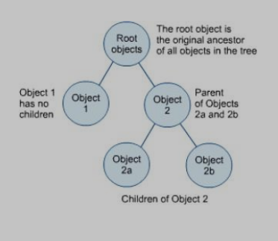
Real-Life Example of Directory Service Hierarchical Structure
To understand this structure, consider a university as a real-life example.
At the top level, there is the University itself. This represents the Root object in directory services. The root is the highest level in the hierarchy, and all other objects in the system come under it.
Under the university, there are different faculties or departments, such as the Faculty of Computer Science, Faculty of Business, and Faculty of Engineering. These departments act as parent objects. They are children of the university (root), but they also contain other objects inside them.
Inside the Faculty of Computer Science, there may be:
- Teachers (user objects)
- Students (user objects)
- Lab Computers (computer objects)
- Department Printer (printer object)
These are child objects of that department.
Each object stores specific information. For example:
- A student object stores name, roll number, and login credentials.
- A computer object stores device name and network address.
- A printer object stores printer name and location.
This hierarchical structure helps in organized management. For example, if the university wants to give all Computer Science students access to a programming lab server, the administrator can apply permission at the department level. All student objects inside that department automatically inherit the permission. This reduces manual configuration.
This structure also improves searching. If the administrator wants to find a specific student, they can navigate through:
University → Faculty of Computer Science → Student Name
Thus, directory services use a tree-like hierarchy in real life to organize resources logically, manage permissions efficiently, and simplify administration.

5. LDAP (Lightweight Directory Access Protocol)
LDAP (Lightweight Directory Access Protocol)
Lightweight Directory Access Protocol is a communication protocol used to access and manage directory services over a network. It works over TCP/IP and defines the rules that a client must follow to communicate with a directory server. LDAP itself does not store any usernames, passwords, or directory data. Instead, it provides a standard method for sending requests such as authentication, searching for users, retrieving group information, or updating directory records. In simple words, LDAP is the language used by client devices to talk to a directory service.
Active Directory and Directory Service
Active Directory is a directory service developed by Microsoft. A directory service is a centralized system that stores and organizes information about network objects such as users, computers, printers, and groups. Active Directory keeps this information in a structured database and allows administrators to manage authentication, authorization, and security policies from one central location. Active Directory uses LDAP as the communication protocol between clients and the directory server. So, LDAP is the method of communication, and Active Directory is the system that stores and manages the data.
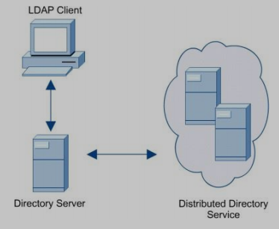
LDAP Client in the Picture
The LDAP client represents a user device such as a computer or an application. When a user attempts to log in or request directory information, the device acts as an LDAP client. It sends a request to the directory server using LDAP rules. The client does not verify passwords or store directory data. Its role is only to send the request and wait for a response from the server.
Directory Server in the Picture
The directory server is the physical or virtual machine that runs the directory service software, such as Active Directory. It contains the actual directory database where usernames, passwords, group memberships, and permissions are stored. When it receives a request from an LDAP client, it processes the request, checks the stored information, and then sends back a response. The directory server performs authentication by verifying credentials and controls access based on stored permissions.
Distributed Directory Service in the Picture
A distributed directory service refers to multiple directory servers working together while maintaining synchronized copies of the same directory data. These servers replicate information between each other so that all copies remain consistent. If one server becomes unavailable, another server can handle authentication and directory requests. This improves reliability, availability, and performance. It ensures that users can still log in and access resources even if one location or server fails.
How Authentication Works (Bind Operation)
When a user enters a username and password, the LDAP client sends a bind request to the directory server. The directory server compares the provided credentials with the stored credentials inside the directory service database. If the information matches, the server authenticates the user and grants access. If it does not match, access is denied. The bind operation is the process that confirms the identity of the user.
Complete Example in Proper Flow
Consider a company with offices in Lahore and Karachi. Both offices have directory servers running Active Directory. These servers are synchronized and form a distributed directory service. When Ali logs into his computer in Lahore, his computer acts as an LDAP client and sends his credentials to the Lahore directory server using LDAP. The directory server checks the credentials stored in its Active Directory database. If the credentials are correct, Ali is granted access. If the Lahore server is unavailable, Ali’s computer can contact the Karachi directory server, which has a replicated copy of the same directory data. The Karachi server then verifies Ali’s credentials and allows access. This complete process demonstrates how LDAP, directory servers, Active Directory, and distributed directory services work together to provide centralized and reliable authentication.

6. Active Directory
Active Directory is a system used to manage users, computers, and resources in a network from one central place. It stores information like usernames, passwords, groups, and permissions in a structured database. It allows administrators to control login, security policies, and access to resources across the entire network.
Active Directory – Logical Structure
Active Directory has a logical structure that is based on units called Domains. A domain is the basic and most important unit in Active Directory. It acts as a security and administrative boundary. This means that all users, computers, and other objects inside a domain share the same database and security rules. The main purpose of a domain is to organize resources and control authentication in a structured way. When a user logs in, their credentials are verified within their domain. Domains make management easier by grouping related objects under one controlled system.
Multiple Domains and Domain Trees
Active Directory can contain multiple domains. These domains are not isolated randomly; they can be organized into a hierarchical structure called a Domain Tree. In a domain tree, there is a parent domain and one or more child domains. These domains usually share a common name structure, which is called a namespace. For example, if the main domain is shinder.net, a child domain can be research.shinder.net.
The purpose of organizing domains into a tree is scalability and logical separation. Large organizations may have different departments or branches that need separate management but still remain connected. A domain tree allows separate administration while maintaining trust relationships between domains.
Forest – Connecting Multiple Trees
Different domain trees can be joined together to form a Forest. A forest is the highest level structure in Active Directory. All domains and trees inside a forest share a common schema and configuration. They automatically trust each other.
The purpose of a forest is to allow very large organizations to combine multiple domain structures under one global system while still maintaining centralized control. It defines the overall security boundary of Active Directory. Everything inside a forest can share resources securely based on permissions.
Organizational Units (OUs)
An Organizational Unit (OU) in Active Directory is a logical container inside a domain that is used to organize users, computers, and other resources in a structured way. It exists within a domain and does not function as a separate domain. The main purpose of an OU is to make management easier by grouping related objects together, such as grouping employees by department, location, or role. This allows administrators to manage specific sets of users without affecting the entire domain.
Imagine a company with a domain called company.com running Active Directory.
Inside this domain, there are three departments:
- HR
- IT
- Finance
Instead of keeping all employees together in one big list, the administrator creates three Organizational Units (OUs):
- HR OU
- IT OU
- Finance OU
Now all HR employees (like Ayesha and Bilal) are placed inside the HR OU. All IT employees (like Ahmed and Sara) are placed inside the IT OU.
Suppose the company wants:
- HR computers to block software installation
- IT department to have full administrative rights
The administrator can apply a restriction policy only to the HR OU without affecting the IT or Finance OUs. This makes management easier and more organized.
Also, the HR manager can be given permission to manage only the HR OU. That manager can reset passwords for HR employees but cannot change accounts in IT or Finance.
Domain Controller (DC)
To use Active Directory, at least one server must be configured as a Domain Controller (DC). A Domain Controller is a server that runs Active Directory services and stores the directory database. It is responsible for authenticating users when they log in and enforcing security policies in the domain. Without a Domain Controller, Active Directory cannot function because there would be no system to verify user credentials or manage domain resources. The purpose of the Domain Controller is to act as the central authority for authentication and security within the domain.
Multiple Domain Controllers and Fault Tolerance
It is recommended to have at least two Domain Controllers in each domain. This is done for fault tolerance, which means the system continues to work even if one server fails. If there is only one Domain Controller and it crashes, users will not be able to log in or access network resources. However, if there are two or more Domain Controllers, one can continue handling authentication if the other goes down. The purpose of having multiple DCs is to increase reliability and ensure continuous service.
Replication
When there are multiple Domain Controllers, they use a process called Replication. Replication is the process of copying directory data from one Domain Controller to another and keeping that data synchronized. This ensures that all Domain Controllers have identical information. For example, if a user changes their password on one DC, replication automatically updates the other DCs. The purpose of replication is to maintain consistency and accuracy of data across all servers in the domain.
Access Control List (ACL)
Each object in Active Directory, such as a user account or folder, has an Access Control List (ACL). The ACL contains all the permissions associated with that object. It defines who is allowed to access or modify the object and who is denied access. Permissions can be explicitly allowed or denied. The purpose of ACLs is to provide fine-grained security control so that only authorized users can access specific resources.
Large Example – Global Company Setup
Company Structure
Imagine a multinational company called TechGlobal.
It has:
- Head Office in USA
- Branch in Pakistan
- Branch in Germany
- 2000 employees
- Multiple departments (HR, IT, Finance, Sales)
To manage everything centrally, TechGlobal installs Active Directory.
Step 1: Creating the Forest
TechGlobal creates one forest called:
techglobal.com
This forest is the highest level. It defines the main security boundary.
Purpose:
To manage the entire global company under one unified structure.
Step 2: Creating Domain Trees
Inside the forest, they create domain trees:
- usa.techglobal.com
- pk.techglobal.com
- de.techglobal.com
Each country has its own domain.
Purpose:
To separate management by region while still being connected under the same forest.
All domains trust each other automatically because they are inside the same forest.
Step 3: Domain Controllers
Each country sets up at least two Domain Controllers.
Example:
Pakistan domain:
- DC1 in Lahore
- DC2 in Islamabad
Purpose:
If DC1 fails, DC2 continues working.
This ensures fault tolerance.
Step 4: Replication
All Domain Controllers inside pk.techglobal.com replicate data.
If Ahmed changes his password in Lahore:
- That update is automatically copied to Islamabad DC.
Purpose:
To keep data consistent across all servers.
Step 5: Organizational Units (OUs)
Inside pk.techglobal.com, they create OUs:
- HR OU
- IT OU
- Finance OU
- Sales OU
Employees are placed inside their respective OUs.
Purpose:
To organize users logically and apply different policies.
Example:
- HR computers cannot install software.
- IT department has admin rights.
Policies are applied to specific OUs.
Step 6: Authentication Flow
Ahmed works in IT department in Pakistan.
When he logs into his computer:
- His computer sends login request to a Domain Controller.
- The Domain Controller checks his credentials in Active Directory.
- If correct → access granted.
- His permissions are checked using ACL.
- He gets access only to allowed resources.
If one Domain Controller fails:
- Another DC handles authentication.
Step 7: Access Control List (ACL)
Suppose there is a shared Finance folder.
ACL rules:
- Finance OU → Allowed full access.
- Other departments → Denied access.
So even though all users exist in the same domain, permissions are controlled at object level.

7. Network Information Service (NIS)
Network Information Service (NIS) is a directory service mainly used in Linux and Unix systems. It is used to centrally manage user accounts, passwords, and system configuration files across multiple computers in a network.
Instead of creating user accounts separately on every Linux machine, NIS allows administrators to store all user information in one central server and share it across the network.
The main purpose of NIS is centralized authentication and simplified user management in Unix/Linux environments.
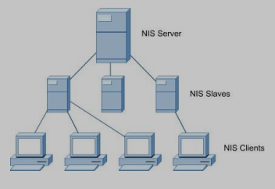
How NIS Works
An NIS system has three main components:
- NIS Server (Master Server)
- NIS Slave Servers
- NIS Clients
The NIS Server stores the main NIS database. This database contains user accounts, passwords, and configuration data.
Slave servers are backup servers. They receive copies of the NIS database from the main server.
Clients are user machines that use NIS to authenticate users.

Large Example of NIS
Imagine a university computer lab with:
- 1 main Linux server
- 2 backup servers
- 50 Linux computers for students
Without NIS:
- Each computer would need separate user accounts.
- If a student changes password, it must be changed on all 50 systems.
- Very difficult to manage.
With NIS:
The administrator creates all student accounts on the NIS Master Server.
The master server stores:
- Usernames
- Passwords
- User IDs
- Group information
This data is copied to the NIS Slave Servers.
Now when a student logs into any of the 50 lab computers:
- The computer (client) contacts the NIS server.
- The NIS server checks the username and password.
- If correct → login allowed.
- If wrong → access denied.
If the main NIS server fails:
- The client contacts one of the slave servers.
- Since slaves have copied data, login still works.
Purpose:
Centralized management + fault tolerance.

